
Microsoft Project 2010 builds on the Microsoft Office Project 2007 foundation with flexible work management solutions and the right collaboration tools for occasional and professional project managers. Project 2010 includes a pathway to more advanced project and portfolio management capabilities as business needs evolve. The Microsoft Project family of products consists of Microsoft Project Standard 2010, Microsoft Project Professional 2010 and Microsoft Project Server 2010.

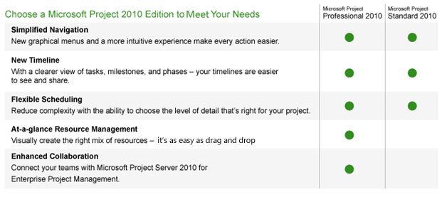

What’s New in Microsoft Project 2010
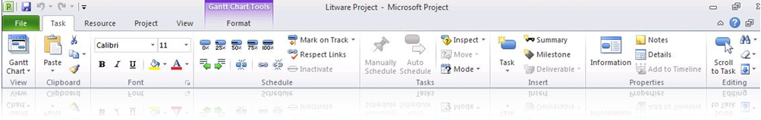
Fluent User Interface — the Ribbon
- Work more efficiently with the simple and intuitive Ribbon, so the tools you need to plan and manage your project are always at your fingertips
- View contextual menu groupings to reveal powerful features, making it easier to get started and realize results
- Learn about features and rich formatting controls quickly with descriptive ToolTips and drop-down galleries
- Simply be more productive by choosing your own menu options, Quick Access Toolbar and setting defaults
- Save to XPS or PDF, share, print, and publish project information easily in the Backstage view

Excel-Like Experience
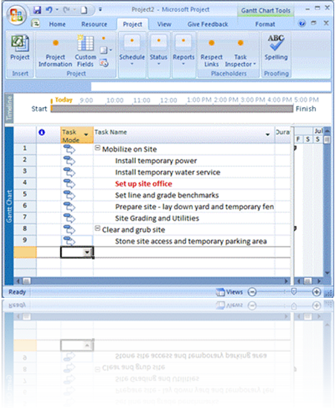
- Use enhanced copy and paste, making it easy to share information effectively with other Office applications while retaining formatting
- Add columns dynamically by entering data without having to first select the data type
- Simplify data entry with auto-complete that displays a list of previously used values to select from
- Use automatic text wrap to eliminate extra formatting steps by adjusting row height to display full task names
- Quickly mine and analyze data with easy access filtering for all columns
- Create emphasis with rich color options and text formatting to express ideas and solve problems in new ways

Flexible Scheduling
- Gain flexibility with user-controlled scheduling — manually schedule tasks with the information you have right now or choose to automatically schedule tasks with calculated dates and durations
- Be alerted to potential scheduling concerns with squiggly lines and choose how to manage them
- Gain insight with the Task Inspector to recognize concerns and take action early — effectively managing to solve problems
- Support rolling wave planning and easily create high-level forecasts using manually scheduled Top Down Summary tasks
- Identify gaps by comparing manually scheduled summary tasks with information rolled up from subtasks
- Simplify planning with inactive and active tasks to perform what-if analysis

Timeline View
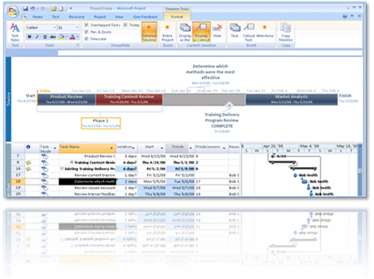
- Simply create the ultimate graphical timeline to express your schedule and plan
- More easily see and share — with a clear view of tasks, milestones and phases
- Pan, zoom, color and enhance with all the visual effects you’d expect to illustrate ideas and connect with others
- Drill into details and visually recognize differences — compare project versions and make informed decisions
- Reach your audience quickly with new impact by copying the timeline into an e-mail message, a presentation or any other document
- Edit, alter or format the copied timeline easily to deliver integrated business insights and benefits

Professional Edition — Team Planner
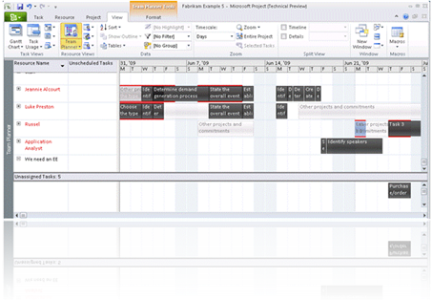
- Visualize the right mix of resources and assignments with a simple and intuitive resource view
- Drag and drop task assignments to save time and optimize resources
- Quickly see and identify unassigned or unscheduled tasks to solve problems
- Simply hover over tasks to instantly see task-level details to plan with ease and precision
- Be alerted to potential problems with visual highlights and choose to manually level resources as you work
- Automatically level over-allocated resources on a task-by-task basis using Task Inspector to instantly realize results

Professional Edition — Connect Teams With SharePoint Sync
- Enhance team collaboration by sharing information more efficiently — simply copy, paste, save, print or publish in one easy-to-manage Backstage view
- Fully utilize the power of Project Professional 2010 by converting Windows SharePoint Services task lists to realize project schedules
- Publish your Project Professional plans to Microsoft SharePoint task lists and enable round-trip synchronization so team members can update task status directly from Microsoft SharePoint Products and Technologies
- Save, share and manage — simply be more connected in the ways you expect with Project Professional 2010 and Windows SharePoint Services
- Connect Project Professional to Microsoft Project Server 2010 and add the capabilities of end-to-end project and portfolio management

What’s New in Microsoft Project Server 2010


Microsoft Project Server 2010 provides unified project and portfolio management to help organizations prioritize investments, align resources and execute projects efficiently and effectively.

Project Server 2010 unifies portfolio management and project management capabilities to help ensure organizations gain control across all types of work, improve investment selection and strategic alignment, maximize resource utilization, enhance productivity through effective collaboration, and visualize performance through powerful dashboards to drive operational efficiency and improved business performance.

Unified Project and Portfolio Management
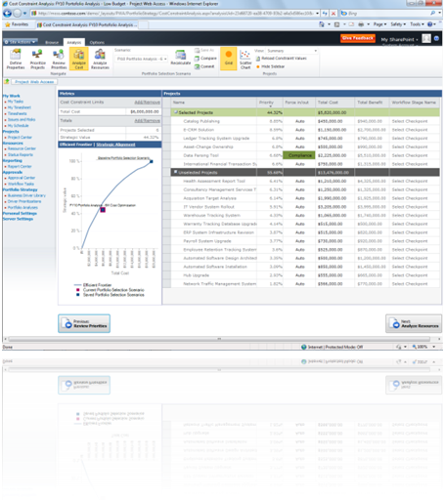
In Microsoft Project 2010 the best-of-breed portfolio management techniques of Microsoft Office Project Portfolio Server 2007 are included in Microsoft Project Server 2010, providing a single server with end-to-end project and portfolio management (PPM) capabilities.
- Familiar SharePoint user interface throughout the solution
- Common data store eliminates the need for the Project Server Gateway
- Intuitive and simplified administration
- Comprehensive application programming interface includes both project and portfolio capabilities

Built on Microsoft SharePoint Server 2010
Microsoft Project 2010 is built on top of Microsoft SharePoint Server 2010, combining powerful business collaboration platform services and structured execution capabilities to provide flexible work management solutions.
- Take advantage of the business intelligence platform to easily create reports and powerful dashboards
- Control document review and approval through workflow
- Use enterprise search to easily find people and effectively mine project data (resources, tasks, documents, etc.)
- Connect teams and enhance communication with wikis, blogs, discussion forums and My Site

Project Initiation and Business Case Development
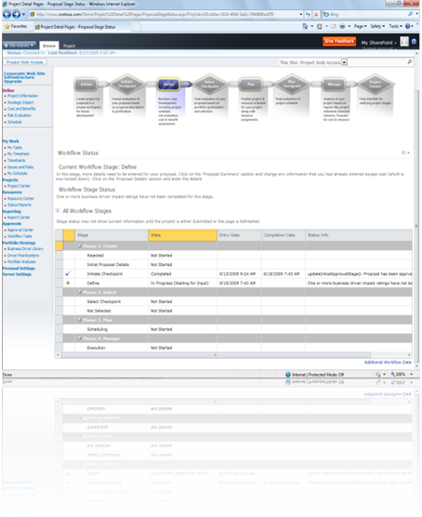
Project Server 2010 provides a new demand management module to capture all work from simple tasks to complex projects and programs.
- Develop and deploy effective governance workflows to manage project investments throughout their life cycle and drive accountability and control
- Define Enterprise Project Types for all requests and associate with workflow, a project plan and custom workspace templates
- Standardize data collection through configurable business case forms; capture project information, cost estimates, resource estimates, strategic alignment assessments and more
- Display relevant Enterprise Project Types for each line of business using departmental fields

Portfolio Selection
Project Server 2010 helps organizations select project portfolios that align with their business strategy by providing techniques to prioritize competing requests, run optimization scenarios under varying budgetary constraints and maximize resource utilization across the planning horizon.

Business Strategy Prioritization
- Objectively prioritize business drivers and drive consensus across the executive team
- Take advantage of intuitive and visual interface for completing the business driver prioritization assessment

Portfolio Prioritization and Optimization
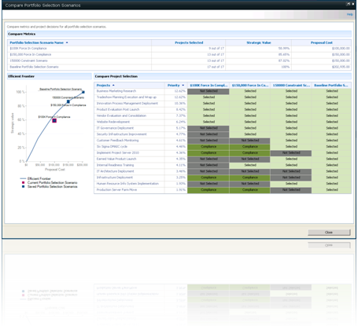
- Effectively prioritize projects from multiple dimensions — strategic value, financial value and risk
- Select the optimal portfolio of projects while meeting budgetary and other constraints
- Use enhanced optimization interface to surface powerful analytical views (e.g., Efficient Frontier) to improve decision-making
- Better understand trade-offs with Force In/Out descriptive values
- Compare optimization scenarios side by side with snapshot scorecard

Capacity Planning
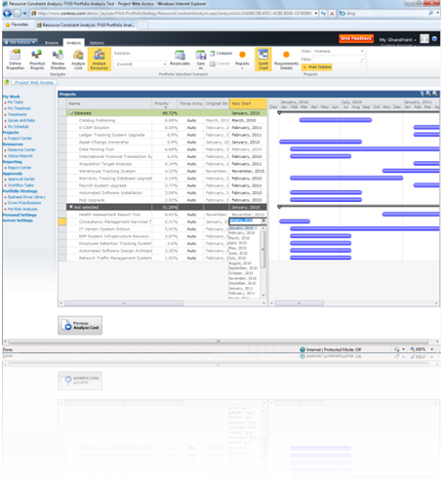
- Gain insight into generic resource demand and availability across the planning horizon
- Reschedule projects within the horizon to maximize resource utilization while adhering to schedule dependencies
- Model head-count decisions and compare scenarios

Web-Based Project Editing
Project Server 2010 brings the power of Project Professional 2010 to the browser with Web-based project scheduling.
- Easily build schedules online and conveniently make simple project edits from virtually anywhere
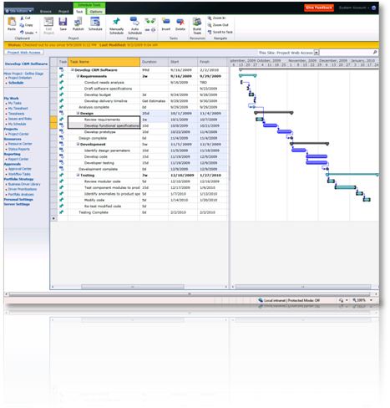
- Gain flexibility with user-controlled scheduling — manually schedule tasks with the information you have right now or automatically schedule tasks to have Project calculate durations and dates
- Create projects with more than 100 tasks, assign multiple resources, and easily define task hierarchy and dependencies
- Gain insight with change highlighting and multilevel undo

Fluent User Interface
- Microsoft Project 2010 delivers a consistent experience across Project Standard 2010, Project Professional 2010 and Project Server 2010 through the Fluent User Interface known as the Ribbon.
- You can work more efficiently with the simple and intuitive Ribbon, so the tools you need to plan and manage your project are always at your fingertips.
- Task-oriented tabs and context-sensitive menu groupings make finding and performing activities easier.
- You can get started quickly with the consistent and familiar SharePoint Server 2010-based interface.

Time Reporting Enhancements
- Save time and unify task status updates and timesheet submissions by enabling Single Entry Mode
- Take advantage of flexible and consistent interface, which enhances the time reporting experience
- Conveniently approve timesheet and task status updates through the consolidated Approval Center
- Simply delegate approvals with enhanced user delegation

Microsoft Exchange Server Integration
- Choose to receive and update your project task status in Microsoft Office Outlook
- View Project tasks, shown as Outlook tasks grouped by project name — no Outlook add-in required
- Stay connected with notifications and updates through Microsoft Office Outlook Web Access or your mobile phone

Enhanced Reporting and Business Intelligence
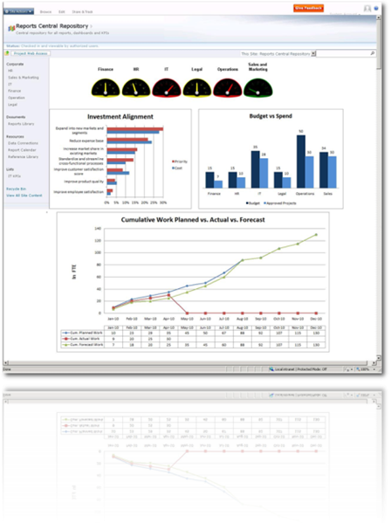
- Experience the strength and depth of Microsoft business intelligence platform; gain transparency and control with Excel Services, PerformancePoint Services, Visio Services and SQL Server Reporting Services
- Get started quickly with predefined best practice and localized report templates in the new Business Intelligence Center
- Intuitively customize reports in a familiar Excel editor and publish through Excel Services
- Simply create powerful audience-based dashboards to effectively monitor portfolio performance
- Satisfy line-of-business reporting requirements with Departmental Cubes; allow decision-makers to focus on their data, eliminate unnecessary clutter and help ensure faster cube build times

Simplified Administration
- Project Permissions. Empower project managers to control who can view or edit their projects with Project Permissions
- User Delegation. With enhanced delegation, enable users to easily specify colleagues to act as their delegate when on vacation, without assistance from the administrator
- Departmental Fields. Provide a level of autonomy while maintaining enterprise standardization and control; with Departmental Fields administrators can associate Enterprise Project Types, Resources and Custom Fields to specific departments, eliminating unnecessary clutter and allowing departments to focus on their data
- Centralized administration. Use one-stop administration console to manage both project and portfolio management capabilities
- Administer Reporting Cubes. Use enhanced administration interface to display status and manage available cubes; quickly take action and intuitively add, edit, delete, copy and refresh cubes

Extend Interoperability
Integration with related Microsoft technologies provides a familiar and connected work management platform. Empower teams to work in their current productivity tools and provide status updates to project stakeholders with minimal effort and administrative overhead
- Exchange Server. Conveniently receive and update your project tasks in Outlook
- Visual Studio Team Foundation Server. Seamlessly connect the worlds of application development and project and portfolio management
- Microsoft Dynamics AX and Microsoft Dynamics SL. Enjoy enhanced financial management and project accounting capabilities through Microsoft Dynamics AX and Microsoft Dynamics SL

This information is about pre-release software and therefore is subject to change. It is provided without warranty of any kind, express or implied.

